INTERNSHIP REPORT

A Report
Submitted in partial fulfillment of the Requirements for the award of the Degree of

MASTERS OF SCIENCE (INFORMATION TECHNOLOGY)

By
Sachin Manoj Sharma FMSC2425179
Under Supervision of
Ms. Seema mam
rsun Technologies Chembur Mumbai
(Duration:- 18 Feb to 15 May)


DEPARTMENT OF INFORMATION TECHNOLOGY
SIES COLLEGE OF ARTS, SCIENCE & COMMERCE (AUTONOMOUS)
SION(W), MUMBAI, 400022
MAHARASHTRA 2024-25

SIES COLLEGE OF ARTS, SCIENCE & COMMERCE(AUTONOMOUS)
(Affiliated to University of Mumbai)
SION(W), MUMBAI-400022

DEPARTMENT OF INFORMATION TECHNOLOGY



CERTIFICATE

This is to certify that the internship report is the Bonafide work of Sachin Manoj Sharma Seat.No: FMSC2425179 submitted for the academic year 2025-26 in partial fulfillment of the requirements for the award of degree of MASTERS OF SCIENCE in INFORMATION TECHNOLOGY.

Sudha Bhagavatheeswaran
Coordinator
Department of Information Technology

Date: College Seal External Examine

LETTER HEAD OF THE Completion



ABSTRACT

This report outlines my internship experience at Rsun Technologies, where I worked as a frontend development intern from February to May 2024. The primary focus was on improving website user interfaces and implementing interactive product visualizations. I contributed to redesigning key sections of the site for better usability and responsiveness and integrated 3D product views to enhance user engagement. This internship provided valuable exposure to real-world UI/UX practices, frontend coding standards, and collaborative development workflows in a professional environment.

ACKNOWLEDGEMENT

I would like to express my sincere gratitude to Rsun Technologies for providing me the opportunity to intern as a Frontend Developer. My heartfelt thanks to Ms. Seema, Manager/TL of the company, for her support and encouragement throughout the internship. I am also grateful to my project supervisor and colleagues for their valuable guidance, timely feedback, and motivation. Their mentorship helped me gain practical skills in frontend development and shaped my understanding of real-world web design practices.

CONTENT

CHAPTER NO. | CHAPTER | PG.NO.
1 | INTRODUCTION:- PROBLEM DEFINITION
2 | THEORETICAL BACKGROUND
3 | SOFTWARE REQUIREMENTS SPECIFICATIONS
4 | ANALYSIS
5 | SYSTEM PLANNING  Gantt chart
6 | SYSTEM IMPLEMENTATION  Code and Screenshots
7 | CONCLUSION
8 | BIBLIOGRAPHY

INTRODUCTION: PROBLEM DEFINITION

As a growing provider of electrical and electronics products, RSun Technologies recognized the importance of a modern, functional, and visually appealing website to reach customers and display their diverse product catalog effectively. However, their existing website lacked responsive design, consistent UI patterns, and an engaging product viewing experience. This created challenges such as poor mobile compatibility, limited user interaction, and a basic layout that did not reflect the technical sophistication of their offerings.
The main problems identified were:
- Non-responsive layout: The previous website design did not adjust well to different screen sizes, leading to a suboptimal experience on mobile and tablet devices.
- Lack of interactive product views: Products were displayed with static images and limited detail, reducing customer engagement and understanding of key features.
- Unoptimized user interface: Navigation was not intuitive, with inconsistent styles and outdated components that negatively impacted user retention.
- No structured product categorization: Items were not clearly grouped or filterable, making it harder for users to find what they needed.
To address these issues, the frontend development team aimed to enhance the website using HTML, CSS, JavaScript, and interactive technologies to implement responsive design, clean layouts, and 3D product visualizations. The goal was to provide a modern digital experience that would reflect the company’s brand, increase user engagement, and support business growth.

THEORETICAL BACKGROUND
Frontend development is a crucial part of web development focused on creating the visual and interactive parts of a website. It involves the use of HTML (structure), CSS (styling), and JavaScript (interactivity) to ensure the website is not only functional but also user-friendly and responsive across all devices.
During my internship, I applied key frontend concepts such as:
- Responsive Web Design (RWD): Ensuring layouts adapt to various screen sizes using CSS Flexbox, Grid, and media queries.
- DOM Manipulation: Using JavaScript to handle user events and update page content dynamically.
- UI/UX Principles: Applying best practices in layout design, color schemes, typography, and accessibility to improve user experience.
- Interactive Visualization: Using JavaScript libraries and 3D product viewers to allow users to interact with product models for a better understanding of features.
- Version Control (Git): Managing code versions and collaborating using GitHub.

SOFTWARE REQUIREMENTS SPECIFICATIONS (SRS)

Functional Requirements:
- Mobile-responsive and device-friendly web layout
- Interactive 3D product visualization for select items
- Smooth navigation with categorized product listing
- Real-time interaction using JavaScript (e.g., image sliders, hover effects)
- Clean product detail pages with specifications and download options
Non-Functional Requirements:
- Cross-browser compatibility
- Fast page loading and optimized assets
- Scalability for future product additions
- SEO-friendly design structure
- Secure code practices and modular architecture
Technologies Used:
- HTML5 – for semantic structure
- CSS3 – for styling, Flexbox/Grid layouts, animations
- JavaScript – for interactivity and DOM manipulation
- Git & GitHub – for version control
- 3D Viewer Plugins – for product visualization
- Browser DevTools – for debugging and performance tuning

ANALYSIS
- Website audit was conducted to review layout, design, and responsiveness.
- UI/UX issues were identified such as poor navigation, lack of interactivity, and mobile optimization.
- Feedback was collected from the internal team to understand key requirements.
- Frontend improvements were planned, including responsive design and 3D product views.
- Development work was completed successfully for the frontend interface.
- Final testing and containerization of the application are still pending before deployment.

System Planning
The internship project at Rsun Technologies was strategically planned over multiple weeks to ensure structured frontend development, feature integration, and preparation for deployment. A modular and milestone-based approach was followed for clarity and flexibility.
Week 1 – Requirement Gathering & UI Planning
- Analyzed the existing website structure and identified key problem areas.
- Collected feedback from the team on what improvements were needed.
- Sketched low-fidelity UI wireframes for the homepage and product sections.
- Defined the design goals for responsiveness, visual clarity, and engagement.
Week 2 – Base Frontend Setup
- Initiated coding of the website layout using HTML, CSS, and JavaScript.
- Set up responsive components using Flexbox and CSS Grid.
- Created navigation menus, banner sections, and footer layout.
- Ensured mobile-first design practices.
Week 3 – UI Enhancement & Product Listing
- Developed product card designs with hover effects and categorized grids.
- Worked on product detail modals/popups for viewing specifications.
- Optimized color schemes and fonts to match company branding.
Week 4 – Firebase Integration for Image Storage
- Connected the frontend with Firebase Cloud Storage.
- Developed an upload feature for product images using the Firebase SDK.
- Enabled dynamic image loading based on real-time database links.
Week 5 – OAuth & Team Login Setup
- Implemented Firebase Authentication using OAuth (Google login).
- Created a secure login system for internal team members to access the admin panel.
- Added user roles and permissions for controlled access.
Week 6 – Product Addition Feature
- Built a form for adding new products via the frontend.
- Connected it with Firebase Realtime Database/Firestore to store product data.
- Ensured data validation and image association during product entry.
- Started functional testing of these modules.
Week 7 – (Pending Work)
- Perform complete UI/UX testing across devices and browsers.
- Optimize asset loading and fix any bugs.
- Containerize the application using Docker to ensure environment consistency and portability.
- Prepare for final deployment to hosting server (e.g., Firebase Hosting or Vercel).

Gantt Chart
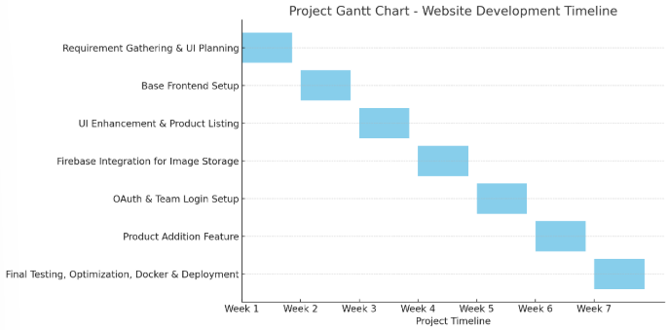

SYSTEM IMPLEMENTATION

The website development was implemented in a modular and structured weekly approach. Each feature was developed, tested, and improved ite
ratively based on feedback and functional requirements. The key modules developed during the project are:
- Homepage & Product UI Design:
Built a responsive homepage and product grid layout with a focus on clean user experience and brand alignment.
- Product Card and Detail View:
Designed interactive product cards with hover effects and modals/popups to display product specifications in detail.
- Firebase Image Storage Integration:
Enabled image upload functionality and dynamic image display using Firebase Cloud Storage and SDK.
- Team Login with OAuth:
Implemented secure team member login using Firebase Authentication with Google OAuth and role-based access control.
- Product Management System:
Created a product addition form linked with Firebase Realtime Database/Firestore, including validation and image linking.
- Final Testing and Docker Setup (In Progress):
Performing UI/UX testing, bug fixes, and preparing the Docker container for consistent deployment. Final hosting is planned via Firebase Hosting or Vercel.
Each module was demonstrated, reviewed, and refined through continuous development cycles.

ScreenShots:
dashboards
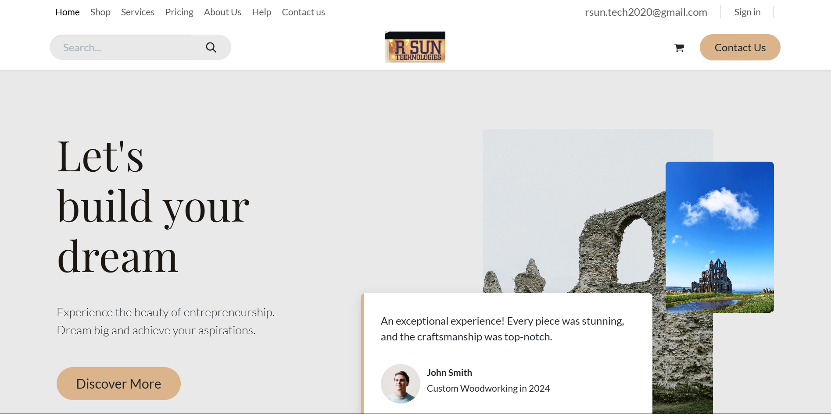

Product Listing
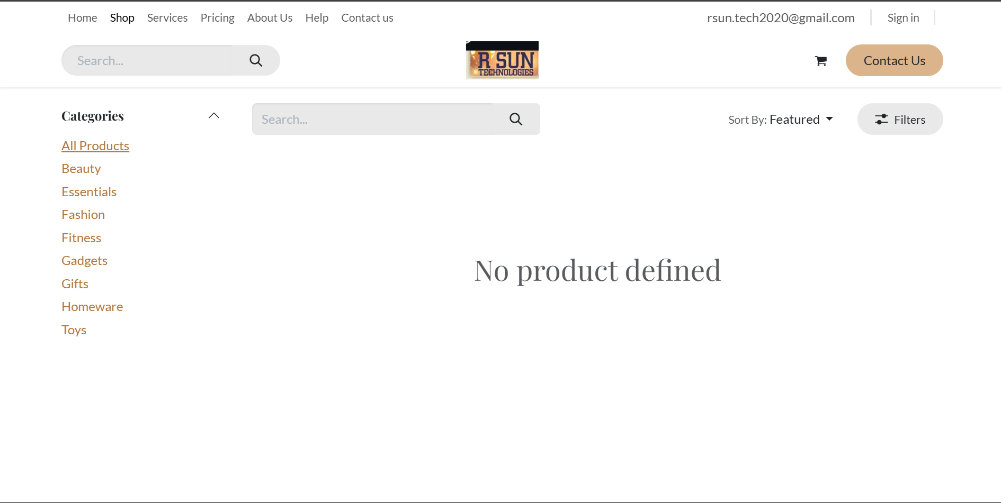

Ticket raise
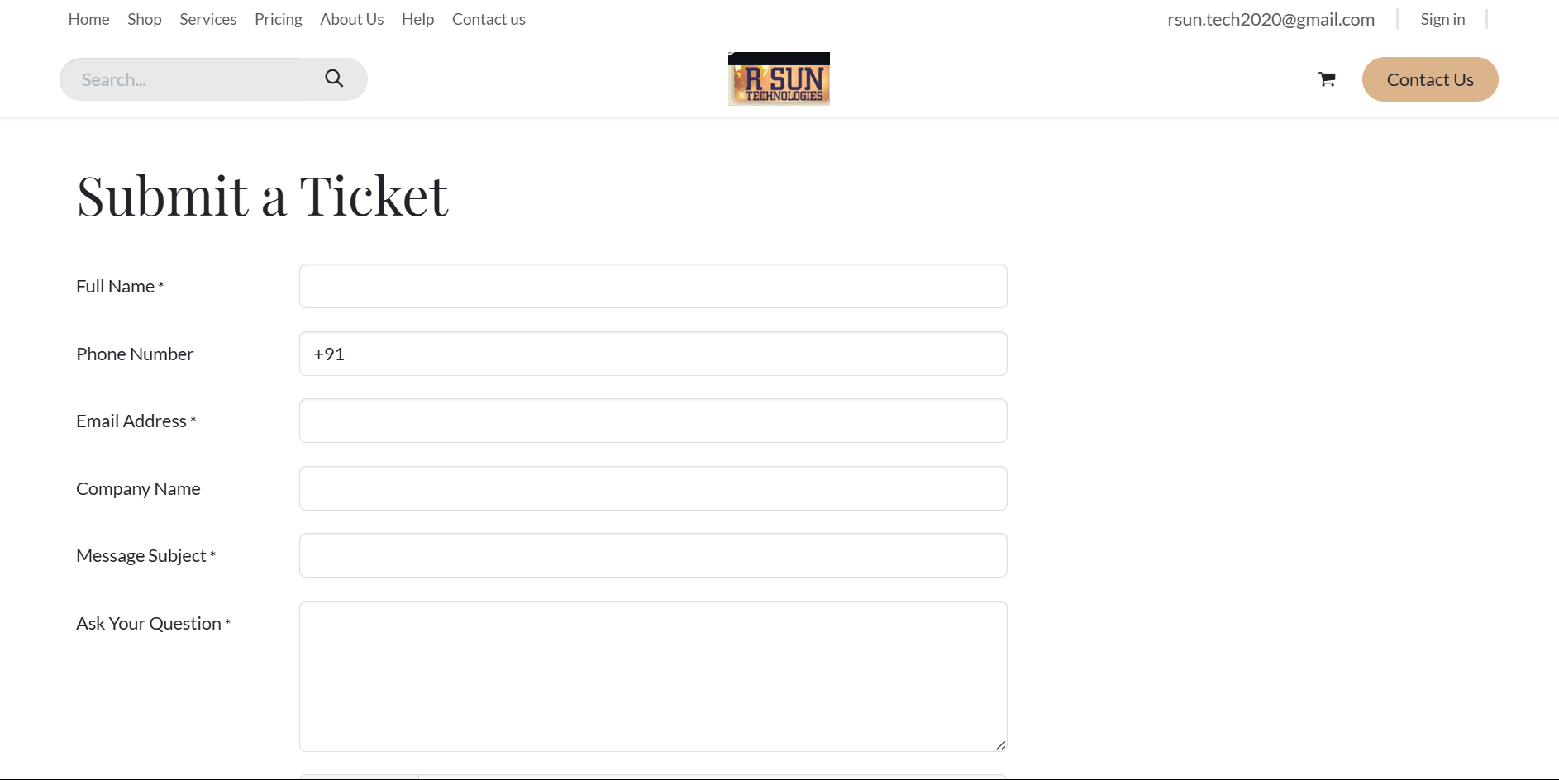

Contact Us page:
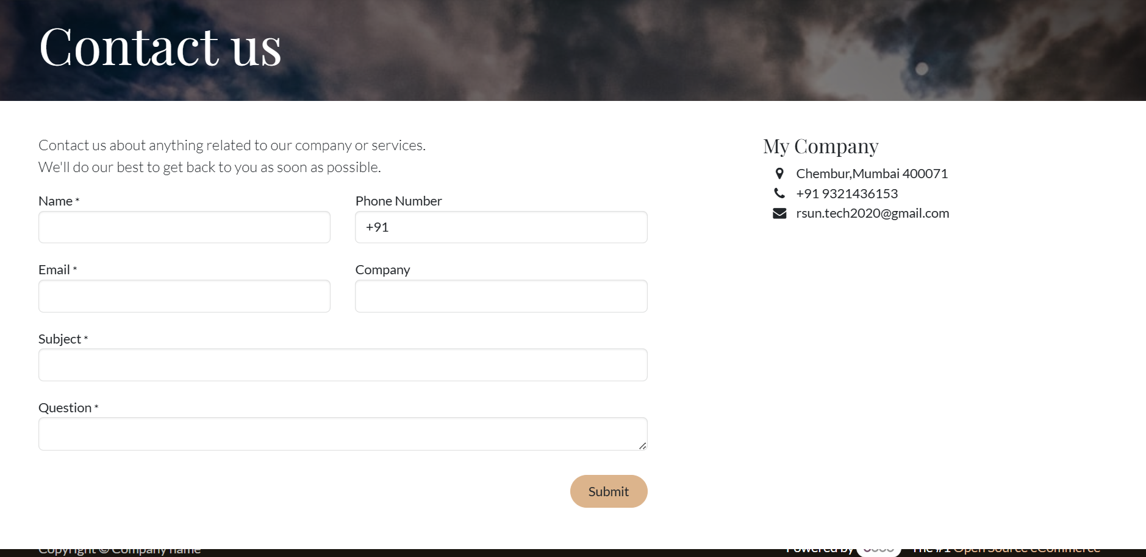

Admin Login Page

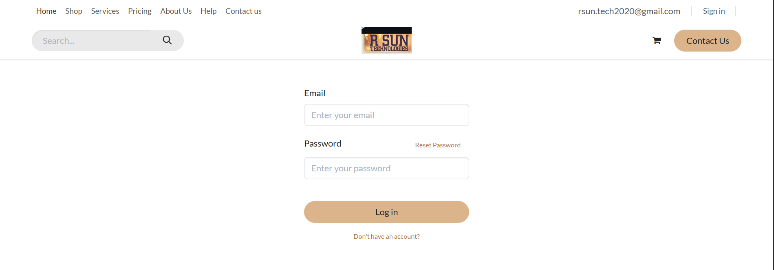

Code
import React, { useEffect, useState } from "react";
import { MdOutlineKeyboardBackspace } from "react-icons/md";
import { RiRefreshFill } from "react-icons/ri";

import { motion } from "framer-motion";
import { useStateValue } from "../context/StateProvider";
import { actionType } from "../context/reducer";
import EmptyCart from "./img/emptyCart.svg";
import CartItem from "./CartItem";
import PayPal from "./PayPal";

// const [checkout, setCheckOut] = useState(false);

const CartContainer = () => {
const [{ cartShow, cartItems, user }, dispatch] = useStateValue();
const [flag, setFlag] = useState(1);
const [tot, setTot] = useState(0);
const [checkout, setCheckOut] = useState(false);

const showCart = () => {
dispatch({
type: actionType.SET_CART_SHOW,
cartShow: !cartShow,
});
};

useEffect(() => {
let totalPrice = cartItems.reduce(function (accumulator, item) {
return accumulator + item.qty * item.price;
}, 0);
setTot(totalPrice);
console.log(tot);
}, [tot, flag]);

const clearCart = () => {
dispatch({
type: actionType.SET_CARTITEMS,
cartItems: [],
});

localStorage.setItem("cartItems", JSON.stringify([]));
};

return (
<motion.div
initial={{ opacity: 0, x: 200 }}
animate={{ opacity: 1, x: 0 }}
exit={{ opacity: 0, x: 200 }}
className="fixed top-0 right-0 w-full md:w-375 h-screen bg-white drop-shadow-md flex flex-col z-[101]"
>
<div className="w-full flex items-center justify-between p-4 cursor-pointer">
<motion.div whileTap={{ scale: 0.75 }} onClick={showCart}>
<MdOutlineKeyboardBackspace className="text-textColor text-3xl" />
</motion.div>
<p className="text-textColor text-lg font-semibold">Cart</p>

<motion.p
whileTap={{ scale: 0.75 }}
className="flex items-center gap-2 p-1 px-2 my-2 bg-gray-100 rounded-md hover:shadow-md cursor-pointer text-textColor text-base"
onClick={clearCart}
>
Clear <RiRefreshFill />
</motion.p>
</div>

{/* bottom section */}
{cartItems && cartItems.length > 0 ? (
<div className="w-full h-full bg-cartBg rounded-t-[2rem] flex flex-col">
{/* cart Items section */}
<div className="w-full h-340 md:h-42 px-6 py-10 flex flex-col gap-3 overflow-y-scroll scrollbar-none">
{/* cart Item */}
{cartItems &&
cartItems.length > 0 &&
cartItems.map((item) => (
<CartItem
key={item.id}
item={item}
setFlag={setFlag}
flag={flag}
/>
))}
</div>

{/* cart total section */}
<div className="w-full flex-1 bg-cartTotal rounded-t-[2rem] flex flex-col items-center justify-evenly px-8 py-2">
<div className="w-full flex items-center justify-between">
<p className="text-gray-400 text-lg">Sub Total</p>
<p className="text-gray-400 text-lg">$ {tot}</p>
</div>
<div className="w-full flex items-center justify-between">
<p className="text-gray-400 text-lg">Delivery</p>
<p className="text-gray-400 text-lg">$ 2.5</p>
</div>

<div className="w-full border-b border-gray-600 my-2"></div>

<div className="w-full flex items-center justify-between">
<p className="text-gray-200 text-xl font-semibold">Total</p>
<p className="text-gray-200 text-xl font-semibold">
${tot + 2.5}
</p>
</div>

{user ? (
<motion.button
whileTap={{ scale: 0.8 }}
type="button"
className="w-full p-2 rounded-full bg-gradient-to-tr from-orange-400 to-orange-600 text-gray-50 text-lg my-2 hover:shadow-lg"
>
Check Out
</motion.button>
) : (
checkout ? (
<PayPal />
) : (

<motion.button onClick={()=>{
setCheckOut(true);
}}
whileTap={{ scale: 0.8 }}
type="button"
className="w-full p-2 rounded-full bg-gradient-to-tr from-orange-400 to-orange-600 text-gray-50 text-lg my-2 hover:shadow-lg"
>
Login to check out
</motion.button>
)
)}
</div>
</div>
) : (
<div className="w-full h-full flex flex-col items-center justify-center gap-6">
<img src={EmptyCart} className="w-300" alt="" />
<p className="text-xl text-textColor font-semibold">
Add some items to your cart
</p>
</div>
)}
</motion.div>
);
};

export default CartContainer;
Since the codebase exceeds 5000 lines, I am unable to share the entire code in this document….

Conclusion
The development of the website was executed in a structured and phased manner, adhering to planned timelines and technical objectives. Each module—from user interface design to backend integration using Firebase—was systematically implemented, tested, and refined to ensure functional accuracy and usability.
The incorporation of responsive design principles, secure authentication mechanisms, and dynamic product management features contributed to the creation of a robust and scalable web application. The use of modern technologies such as HTML, CSS, JavaScript, and Firebase enabled efficient development and integration of key functionalities.
Although some tasks such as final testing and deployment are in progress, the project has successfully met its primary goals. The experience gained through this project has not only strengthened technical competencies but also enhanced understanding of real-world development workflows, collaboration, and agile implementation strategies.

Bibliography

Firebase Documentation
https://firebase.google.com/docs

MDN Web Docs – HTML, CSS, and JavaScript
https://developer.mozilla.org/

W3Schools – Web Development Tutorials
https://www.w3schools.com/

Google OAuth Documentation
https://developers.google.com/identity

Docker Documentation
https://docs.docker.com/

YouTube Tutorials on Responsive Web Design and Firebase Integration
https://www.youtube.com/watch?v=kmU7uX3ZHJc
https://youtu.be/ayRQ_GV3LXY?feature=shared
https://youtu.be/UjPpvf4TNLI?feature=shared

Stack Overflow
https://stackoverflow.com/ – Community support for debugging and implementation references.

Chatgpt
  - https://chatgpt.com/
for debugging and problem solving.

